# Phase 2

## Snippets of important code

### Connection_handler.py:

* Accepts TCP connections on port 80 and using threads to handle multiple connections at the same time

* Handling the connection is about receiving the preface for the HTTP2 connection and exchanging the settings frame

* For exchanging the settings frame, it starts by receiving the settings frame of the client and storing it for future usage then sending the server’s settings frame then sending the server acknowledgement for receiving the client settings frame and receiving the client acknowledgement

### Frame_processor.py:

* Frame processor should handle the frames coming from the client and send it where it belongs, but some frames before that it should go to the stream manager first and we will see that later

### Stream_manager.py:

* This file is responsible for managing the streams states and also the flow control
* The stream manager receives every frame and check its stream id and if it has new stream id it adds it and if not it manages its state
* The other part which is the flow control it keeps track of window frame of each of connecting and the stream and when the window is full it sends/receive a window update frame

### HPACK.py:

* This module is one of the most complex and important modules as it is responsible for receiving the HEADER FRAME as encoded compressed bytes and converting it into readable headers
* It contains of the static table:

* Dynamic table class:

* Encoding functions that encodes headers into encoded compressed bytes:

* Decoding functions that decode into normal headers:

### Frames.py:

Class frame is made managing the frames properly

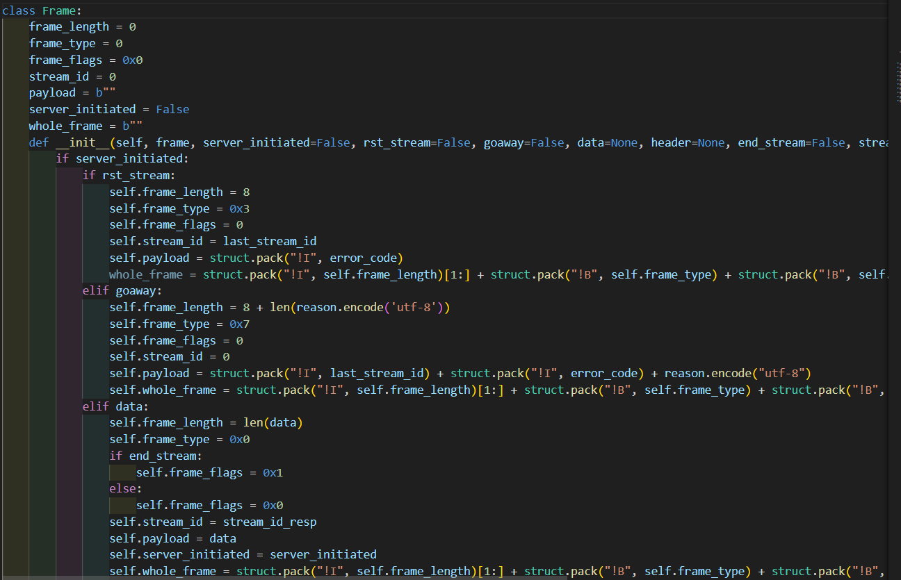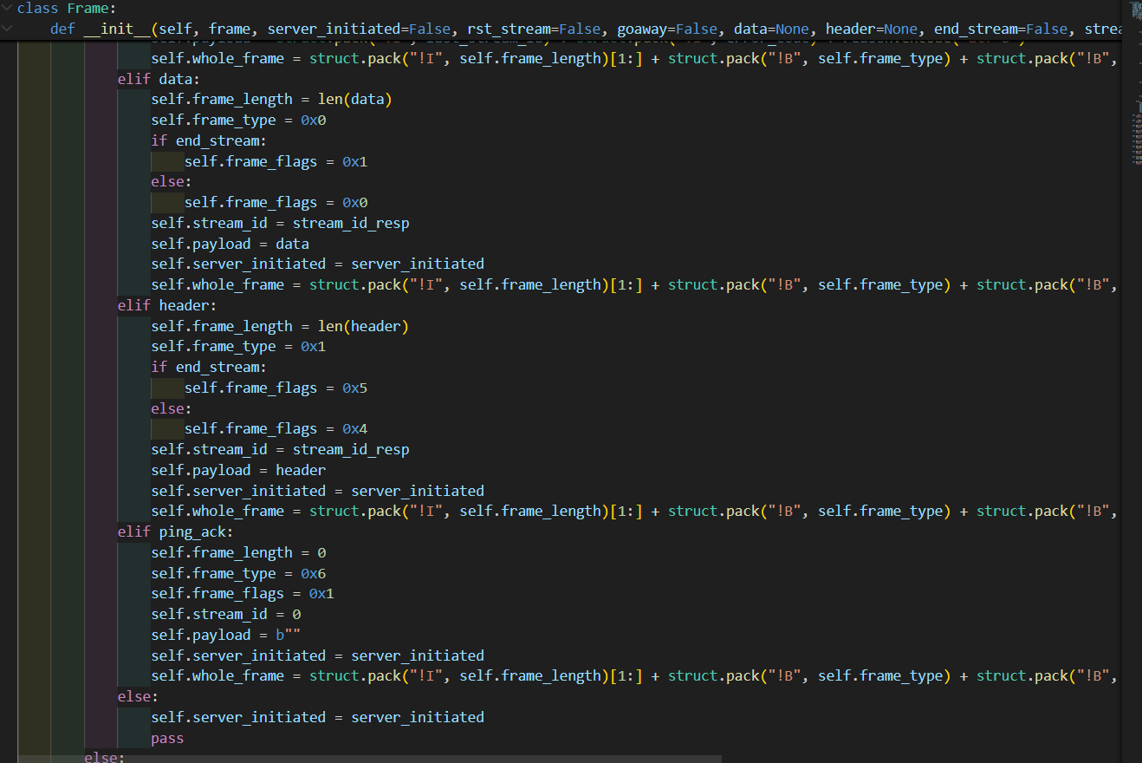

### Database.py:

### Server_settings.json:

This made for saving the server settings that will be sent while exchanging the SETTINGS FRAME

### Error_handling.py:

provides essential functions for managing HTTP/2 connection and stream errors, constructing appropriate error frames, and ensuring that these frames are sent to the client, followed by proper connection or stream termination.

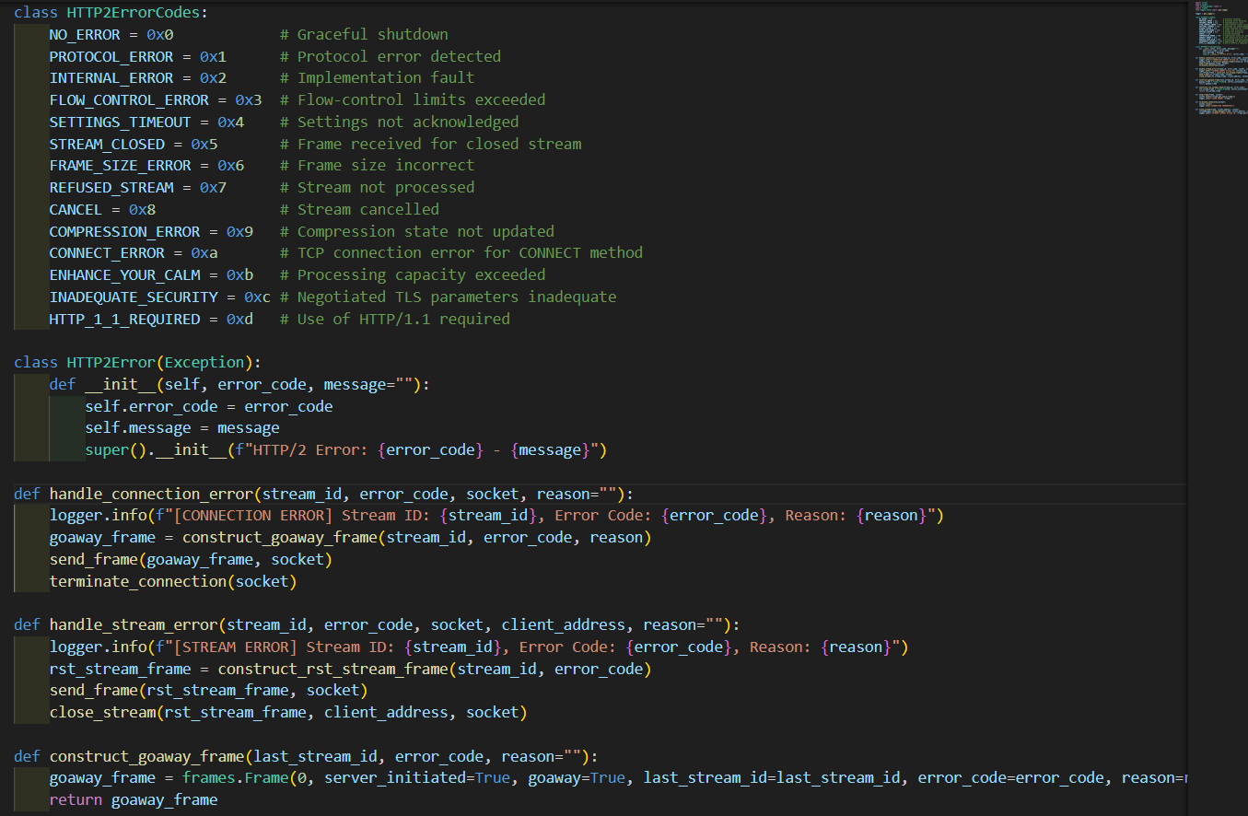

### parsing_header_data.py:

processes HTTP/2 frames, extracts and handles request headers and bodies, and constructs appropriate HTTP/2 response frames. It includes functions to parse data frames, handle end-of-stream conditions, and manage the construction and sending of response frames. The file ensures proper encoding of headers and segmentation of data for transmission

### How to host your website:

The [parsing_header_data.py](vscode-file://vscode-app/d:/Yusuf/Coding/Programs/Microsoft%20VS%20Code/Microsoft%20VS%20Code/resources/app/out/vs/code/electron-sandbox/workbench/workbench.html) file processes HTTP/2 frames, extracts request headers and bodies, and constructs response frames.

The [SimpleWebsite](vscode-file://vscode-app/d:/Yusuf/Coding/Programs/Microsoft%20VS%20Code/Microsoft%20VS%20Code/resources/app/out/vs/code/electron-sandbox/workbench/workbench.html) class in [website.py](vscode-file://vscode-app/d:/Yusuf/Coding/Programs/Microsoft%20VS%20Code/Microsoft%20VS%20Code/resources/app/out/vs/code/electron-sandbox/workbench/workbench.html) handles web requests and generates responses.

The [create_response](vscode-file://vscode-app/d:/Yusuf/Coding/Programs/Microsoft%20VS%20Code/Microsoft%20VS%20Code/resources/app/out/vs/code/electron-sandbox/workbench/workbench.html) function in [SimpleWebsite](vscode-file://vscode-app/d:/Yusuf/Coding/Programs/Microsoft%20VS%20Code/Microsoft%20VS%20Code/resources/app/out/vs/code/electron-sandbox/workbench/workbench.html) creates HTTP/2 response headers and body, which are used by [parsing_header_data.py](vscode-file://vscode-app/d:/Yusuf/Coding/Programs/Microsoft%20VS%20Code/Microsoft%20VS%20Code/resources/app/out/vs/code/electron-sandbox/workbench/workbench.html) to construct and send responses.

### Testing using browser:

